BURGER SALES SQL QURIES

1. KPI’s
2. Total Revenue:

SELECT SUM(TOTAL_PRICE) AS TOTAL_REVENUE FROM BURGER_SALES

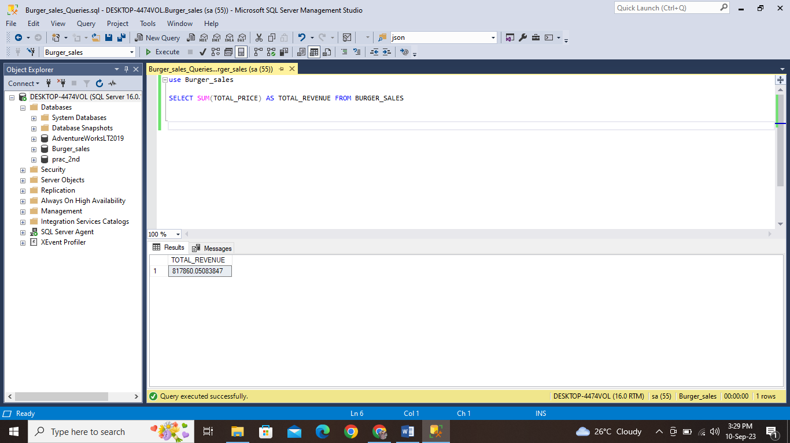

1. Average Order Value:

SELECT (SUM(TOTAL_PRICE) / COUNT(DISTINCT ORDER_ID)) AS AVG_ORDER_VALUE FROM BURGER_SALES

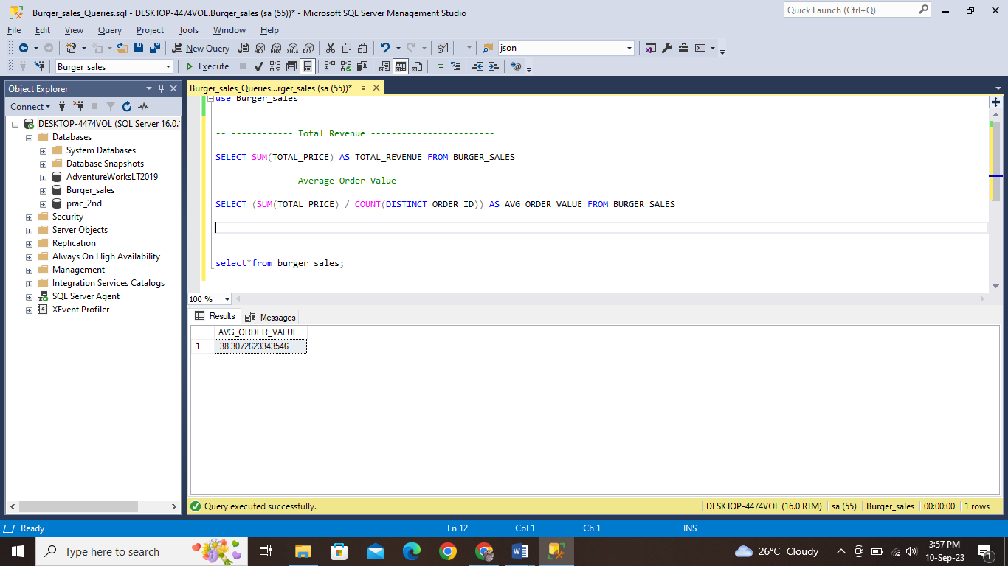

1. TOTAL BURGERS SOLD:

SELECT SUM(QUANTITY) AS TOTAL_BURGERS_SOLD FROM BURGER_SALES

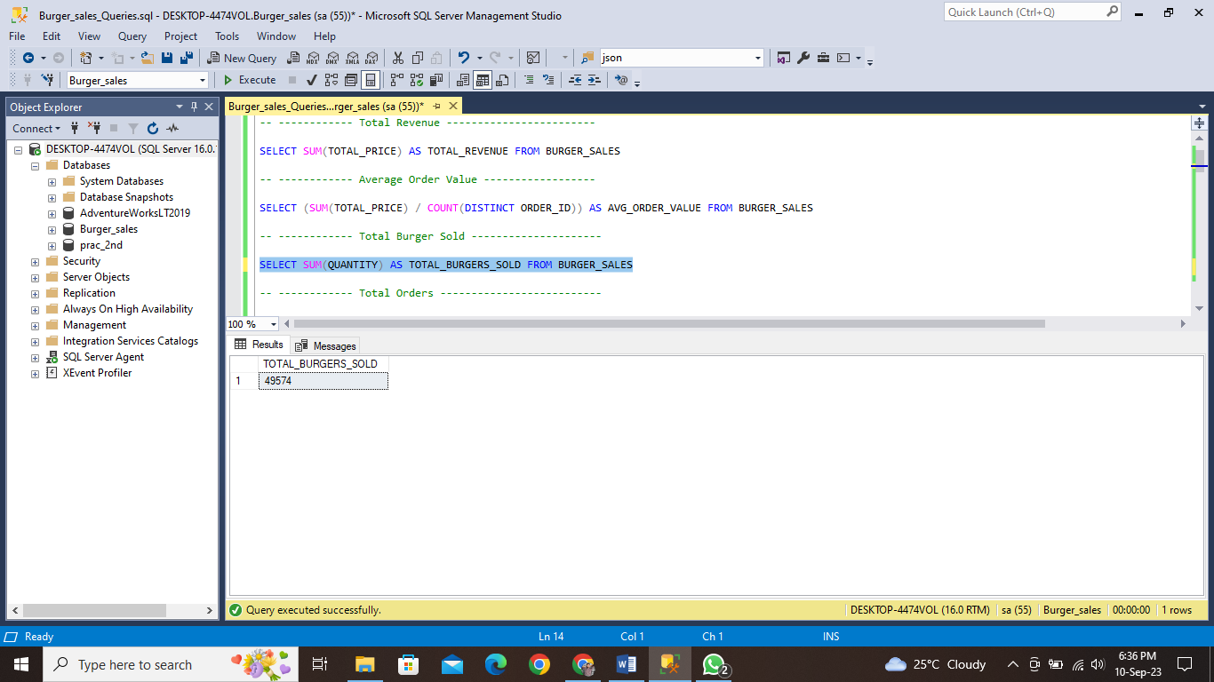

1. TOAL ORDERS:

SELECT COUNT(DISTINCT ORDER_ID) AS TOTAL_ORDERS FROM BURGER_SALES

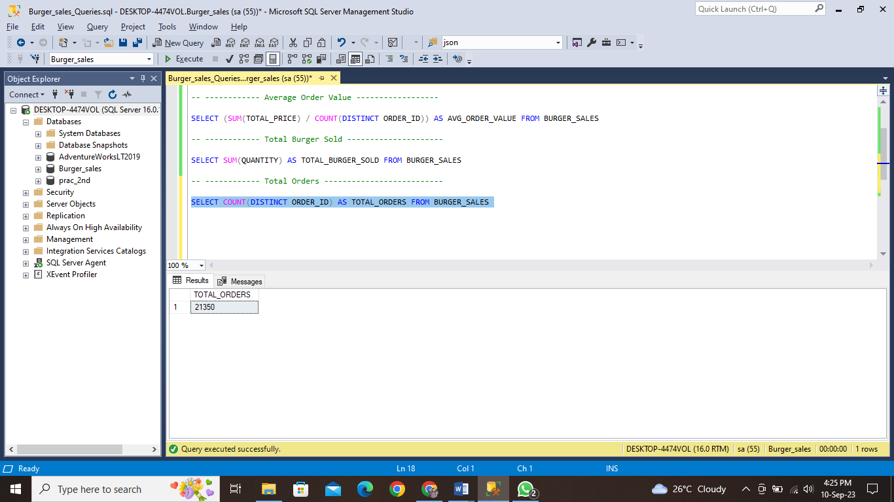

1. AVERAGE BURGER PER ORDER:

SELECT CAST(CAST(SUM(QUANTITY) AS DECIMAL(10,2)) / (COUNT(DISTINCT ORDER_ID)) AS DECIMAL(10,2)) AS AVG_BURGER_PER_ORDER FROM BURGER_SALES

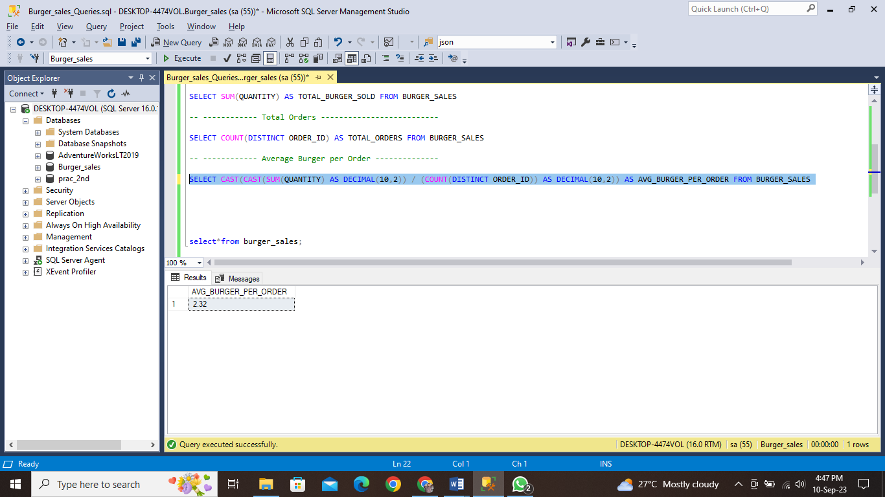

1. DAILY TREND FOR TOTAL ORDERS:

SELECT DATENAME(DW,ORDER_DATE) AS [ORDER DAY], COUNT(DISTINCT ORDER_ID) AS TOTAL_ORDERS FROM BURGER_SALES GROUP BY DATENAME(DW,ORDER_DATE)

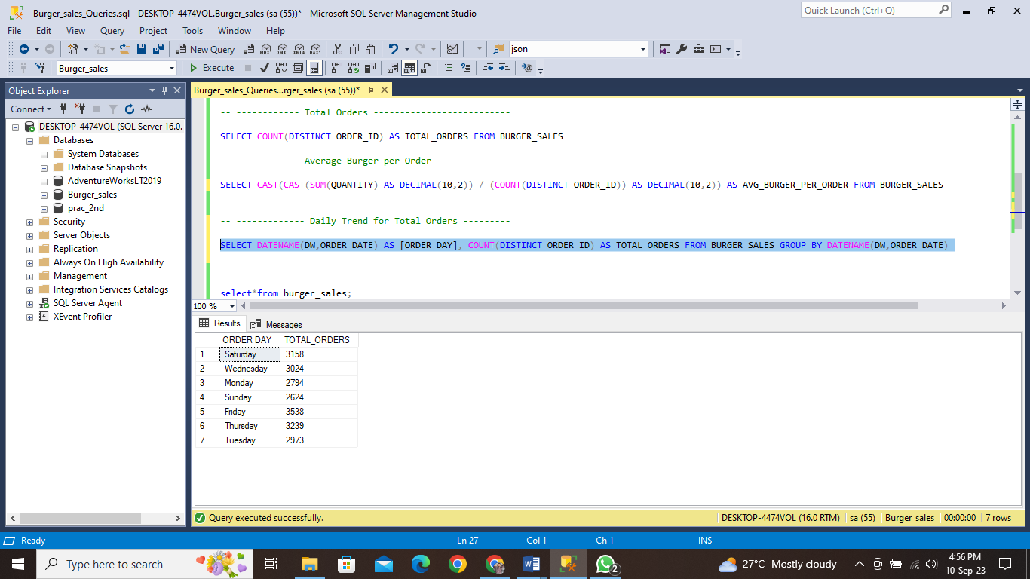

1. MONTHLY TREND FOR TOTAL ORDERS:

SELECT DATENAME(MONTH,ORDER_DATE) AS [ORDER MONTH], COUNT(DISTINCT ORDER_ID) AS

TOTAL_ORDERS FROM BURGER_SALES GROUP BY DATENAME(MONTH,ORDER_DATE)

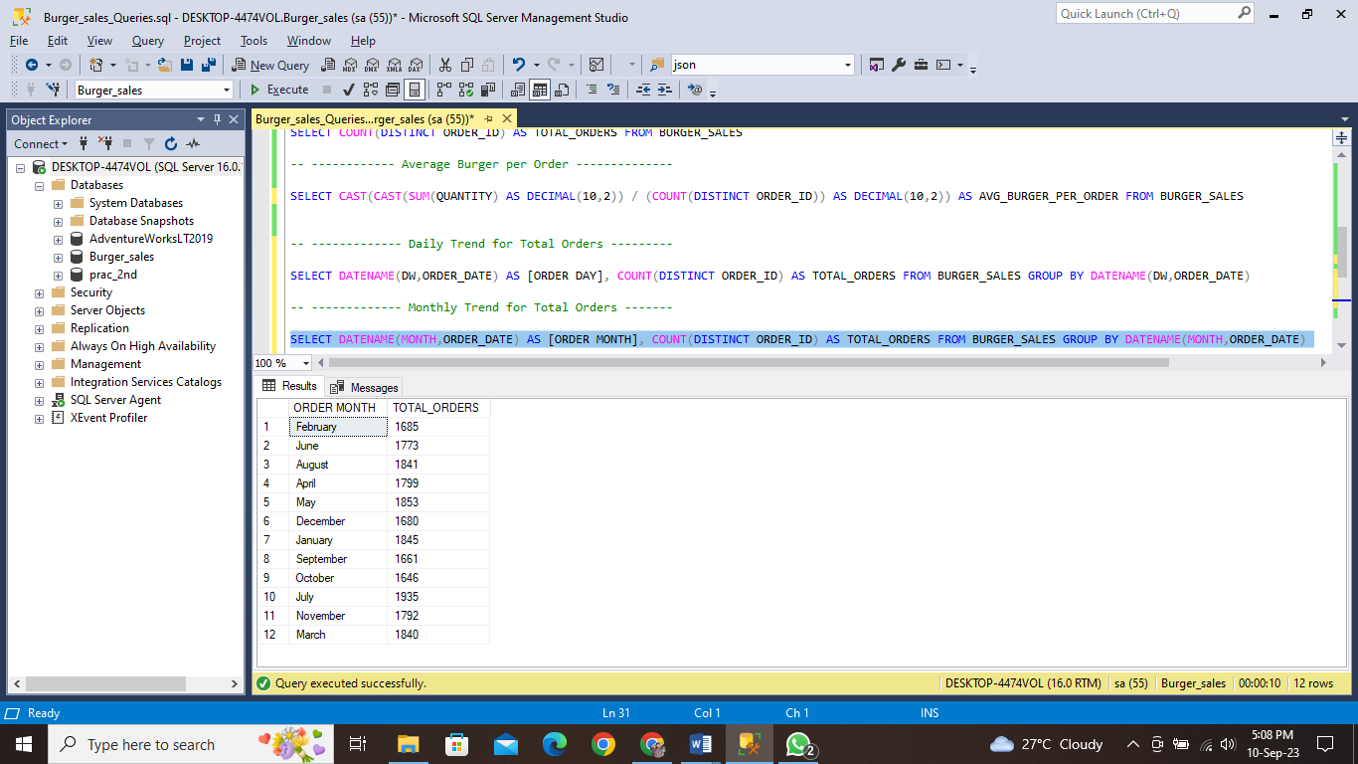

1. PERCENTAGE OF SALES BY BURGER CATEGORY:

SELECT BURGER_CATEGORY,CAST(SUM(TOTAL_PRICE) AS DECIMAL(10,2)) AS TOTAL_REVENUE,

CAST(SUM(TOTAL_PRICE)*100 / (SELECT SUM(TOTAL_PRICE) FROM BURGER_SALES) AS

DECIMAL(10,2)) AS PCT

FROM BURGER_SALES GROUP BY BURGER_CATEGORY

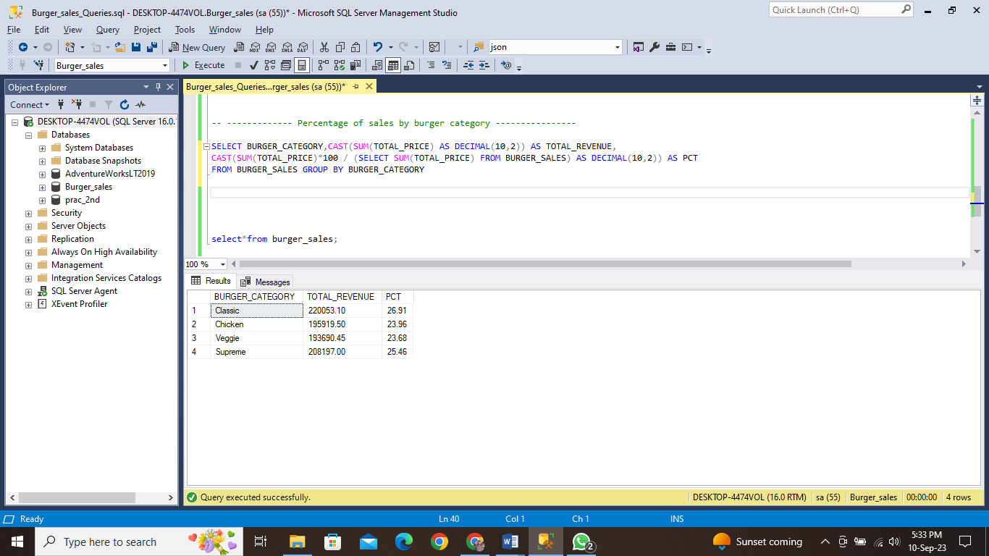

1. PERCENTAGE OF SALES BY BURGER SIZE:

SELECT BURGER_SIZE,CAST(SUM(TOTAL_PRICE) AS DECIMAL(10,2)) AS TOTAL_REVENUE,

CAST(SUM(TOTAL_PRICE)*100 / (SELECT SUM(TOTAL_PRICE) FROM BURGER_SALES) AS DECIMAL(10,2)) AS PCT

FROM BURGER_SALES GROUP BY BURGER_SIZE ORDER BY BURGER_SIZE

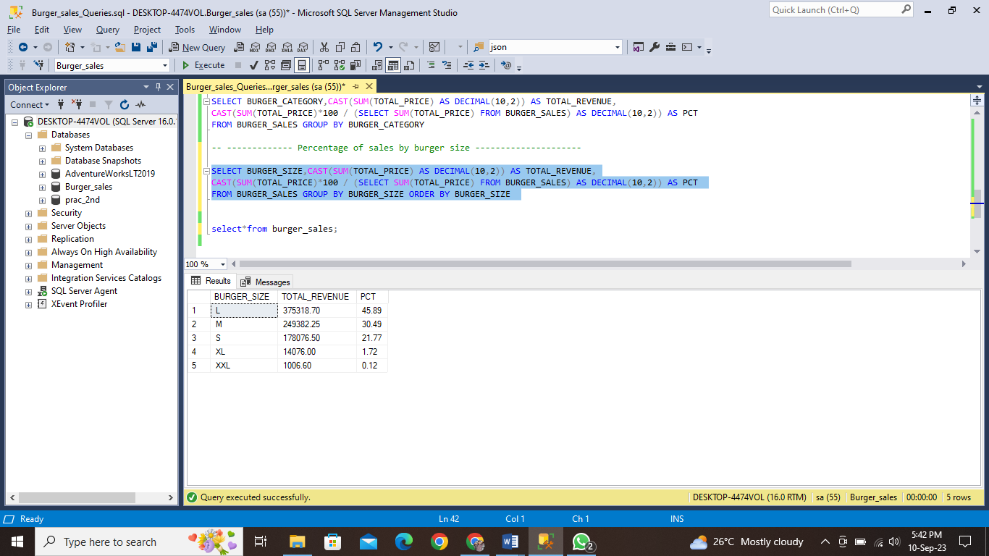

1. TOTAL BURGERS SOLD BY BURGER CATEGORY:

SELECT BURGER_CATEGORY,SUM(QUANTITY) AS [TOTAL QUANTITY SOLD]

FROM BURGER_SALES GROUP BY BURGER_CATEGORY

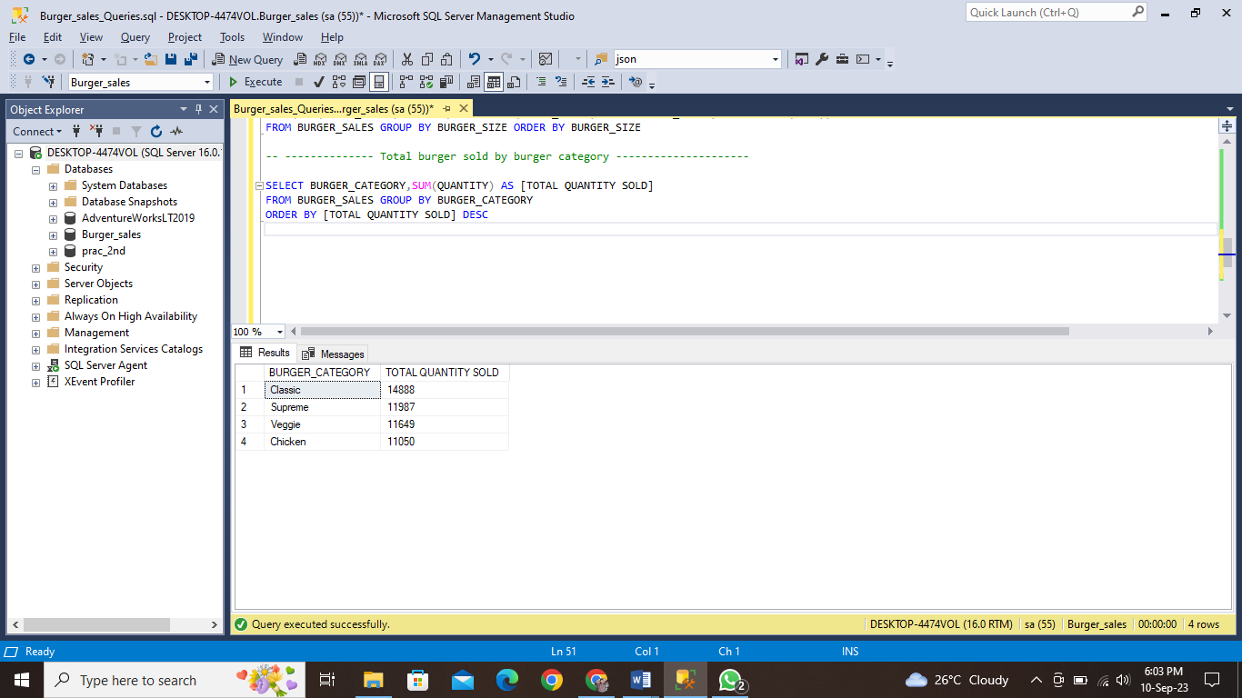ORDER BY [TOTAL QUANTITY SOLD] DESC

1. Top 5 BURGERS BY REVENUE:

SELECT TOP 5 BURGER_NAME,SUM(TOTAL_PRICE) AS TOTAL_REVENUE FROM BURGER_SALES

GROUP BY BURGER_NAME

ORDER BY TOTAL_REVENUE DESC

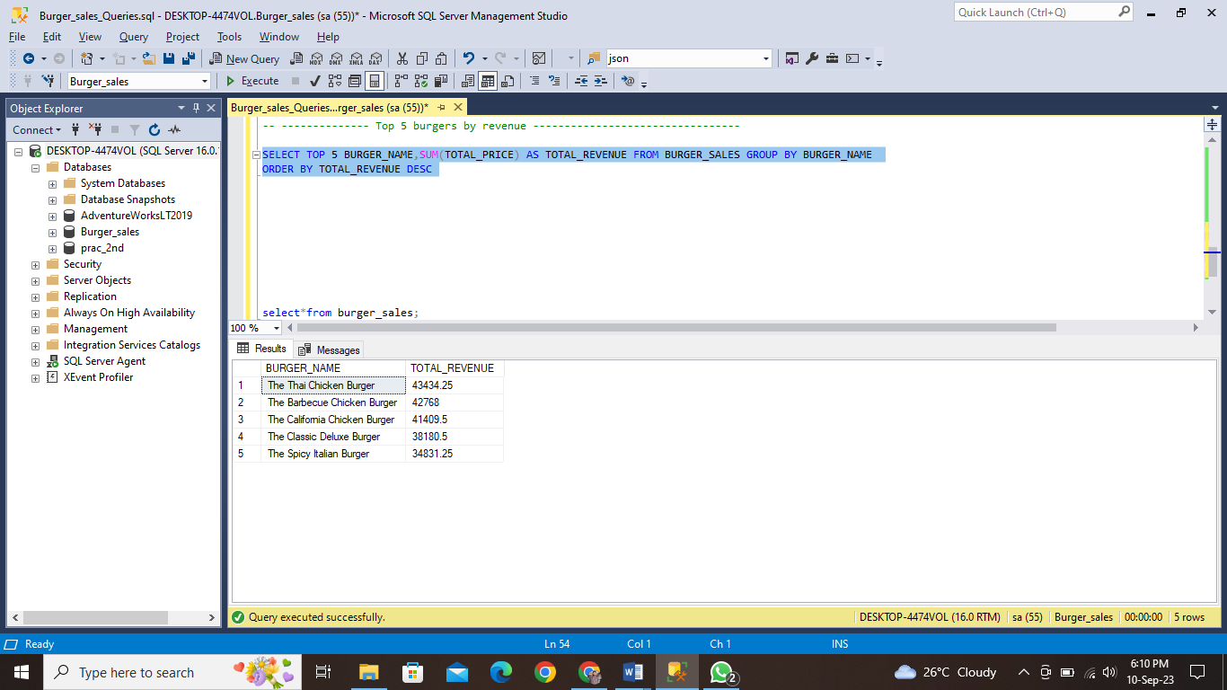

1. BOTTOM 5 BURGERS BY REVENUE:

SELECT TOP 5 BURGER_NAME,SUM(TOTAL_PRICE) AS TOTAL_REVENUE FROM BURGER_SALES

GROUP BY BURGER_NAME

ORDER BY TOTAL_REVENUE

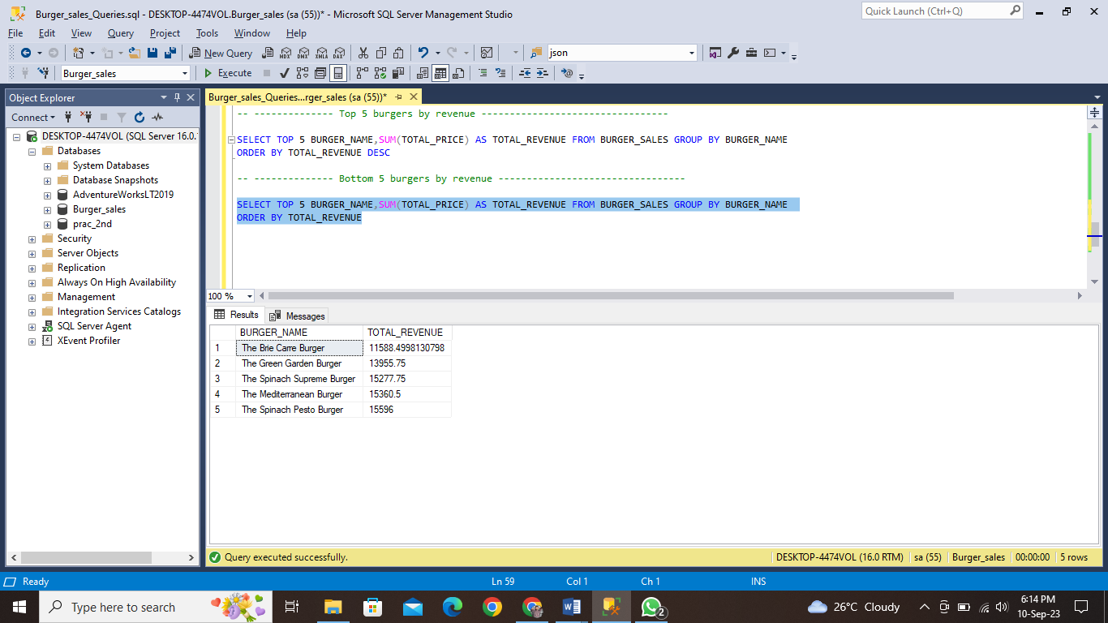

1. Top 5 BURGERS BY QUANTITY:

SELECT TOP 5 BURGER_NAME,SUM(QUANTITY) AS TOTAL_BURGERS_SOLD FROM BURGER_SALES

GROUP BY BURGER_NAME

ORDER BY TOTAL_BURGERS_SOLD DESC

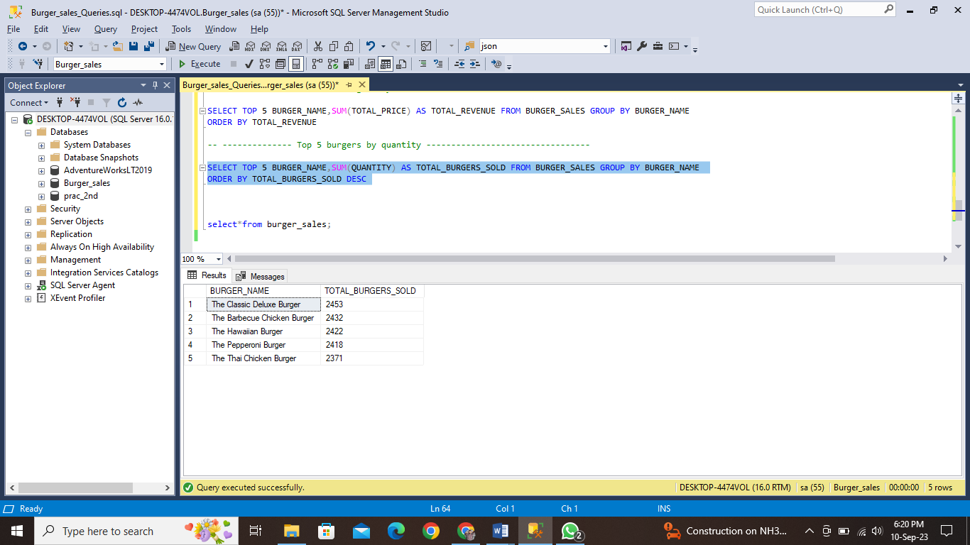

1. BOTTOM 5 BURGERS BY QUANTITY:

SELECT TOP 5 BURGER_NAME,SUM(QUANTITY) AS TOTAL_BURGERS_SOLD FROM BURGER_SALES

GROUP BY BURGER_NAME

ORDER BY TOTAL_BURGERS_SOLD

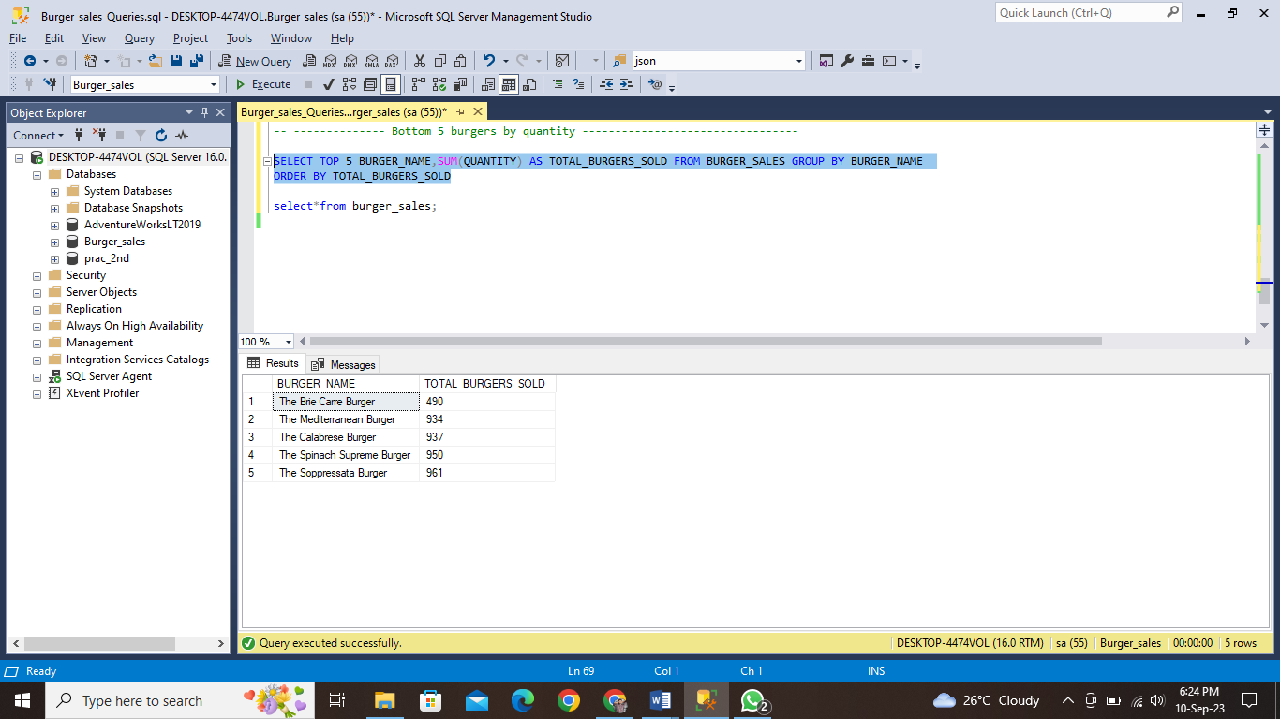

1. Top 5 BURGERS BY TOTAL ORDERS:

SELECT TOP 5 BURGER_NAME,COUNT(DISTINCT ORDER_ID) AS TOTAL_ORDERS FROM

BURGER_SALES GROUP BY BURGER_NAME

ORDER BY TOTAL_ORDERS DESC

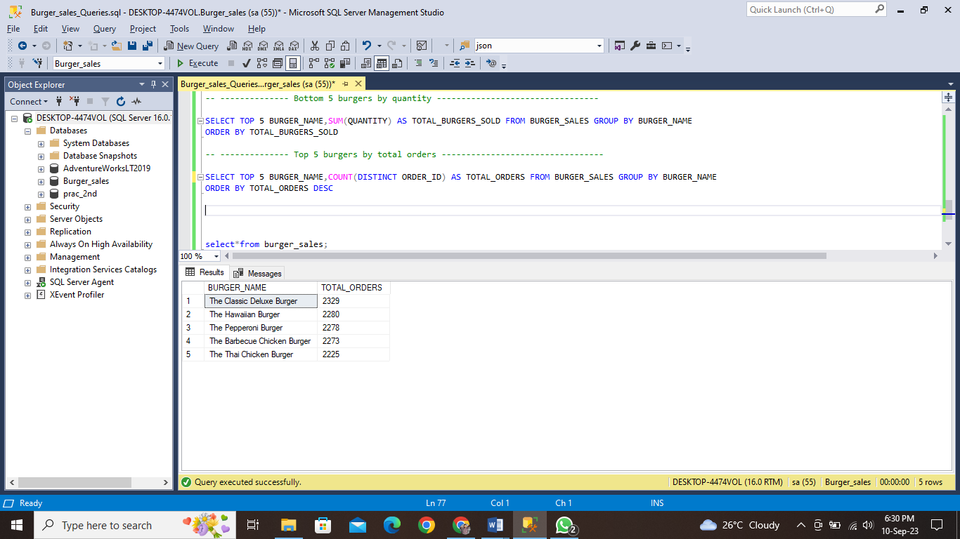

1. BOTTOM 5 BURGERS BY TOTAL ORDERS:

SELECT TOP 5 BURGER_NAME,COUNT(DISTINCT ORDER_ID) AS TOTAL_ORDERS FROM

BURGER_SALES GROUP BY BURGER_NAME

ORDER BY TOTAL_ORDERS

